Booking Form
May Holiday Club 2024
Open Tuesday 28th May – Friday 31st May
At Barnwood C of E Primary School
for children from Reception to 12 years old.

Child’s Full Name | Age in Years
Closing date for bookings is Wednesday 22nd May 2024
Terms and Conditions
- Bookings will be confirmed upon receipt of a completed and signed booking form, accompanied by a £30 deposit per child.
- Full remaining balances must be paid by Wednesday 22rd May. We reserve the right to deny admission to the club in the event of non-payment.
- Sibling Rates do not apply to this offer.
- Cancellations will be refunded in full when at least 2 weeks’ written notice is received and at 50% when 1-2 weeks’ notice is given. Cancellations within 7 days will not be refunded.
- An all-day session is from 8am – 5pm.
- Please provide your child with a packed lunch. (We are a nut free setting.)

Please enter your required session dates and use one form per child.

Date | Day | () | Session Cost £ | Special Instructions/Trips Required.
Monday 27th May | Monday | Closed
Tuesday 28th May | Tuesday
Wednesday 29th May | Wednesday
Thursday 30th May | Thursday
Friday 31st May | Friday
Total Cost £

Payment method (please circle) | BACS:  Sort Code 20-33-83 Account Number 60684716 (Reference child’s name) | Tax Free Childcare | Voucher | Cash

Session Charges

Holiday Full Day (8am-5pm) | £36 | Holiday Full Day Sibling | £32

May 2024 Trips and Events

Trip / Event | Date and Time | Cost | Special Instructions | Tick to book
Cinema Trip  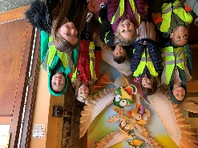 | Wednesday 29th May 2024  10am-12.30pm | £8.50 | We will be leaving club at 9.15am
Picnic at the Arboretum  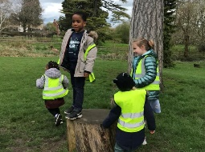 | Thursday 30th May 2024  10am – 1pm | N/A | Weather Dependant
Create our own clay insects! | Friday 31st May 2024 | N/A | N/A

To book a place, please complete and sign this booking form and send it to Holiday Club, All My Friends Childcare, 87 Barnwood Road, Gloucester, GL2 0SF, email it to ASC@allmyfriendschildcare.co.uk, or hand it in person to the
Manager at the Club.

Please note any allergies or intolerances that your child has: |  | Office use only:  Child details recorded on the control list?
I do / do not (please circle)  give permission for All My Friends to use my child’s photograph for social and promotional literature. | Print Name:  ____________________________________________  Relationship to child:  ____________________________________________ | Signature:  ________________________________________

Date Received: _____________________________________ (For Office Use)

Full Payment Received: ______________________________ (For Office Use)

Child Allergy/Intolerance Recorded: ___________________ (For Office Use)
Signed: | Date:
Telephone Number

Email Address:
(so we can contact you regarding your booking).

www.allmyfriendschildcare.com

